

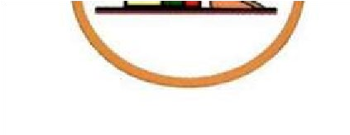

**Cairo University Faculty of engineering**

**Aerospace department**

**Compressor design**

**And off-design project**

**Team (14)**

|  |  |  |
| --- | --- | --- |
| SEC | BN | الاسم |
| 1 | 4 | احمد صلاح محمد |
| 1 | 33 | عبدالله هاني عبدالله |
| 2 | 4 | ماركو جمال فكري |
| 2 | 17 | محمد شيخ الدين اسماعيل |
| 2 | 35 | نور الدين مصطفى احمد |

Contents

**1. Design problem** 4

**1.1 Givens** 4

**1.2 assumption** 4

**1.3 Choosing values from given table.** 4

**1.4 Calculations** 5

1.4.1 Compressor total temperature ratio 5

1.4.2 Velocity triangles 5

1.4.3 Velocity triangle 1 6

1.4.4 Velocity triangle 2 6

1.4.5 Stage Work 7

1.4.6 Stage temperature increase 7

1.4.7 number of stages 7

1.4.8 Total compressor work 7

1.4.9 calculation of solidity 7

1.4.10 calculation of temperatures and pressures 8

1.4.11 Stage adiabatic efficiency 9

1.4.12 Geometry 10

1.4.13 Calculation of Mach number at different stages 11

1.4.14 Blade angles 12

1.4.15 estimating axial compressor length and number of blades 14

**2.** **Off design problem** 14

**2.1** **Inlet Gide vanes’ function** 15

**2.2** **Off design Calculations function** 15

**2.3** **Fitting of The Losses Curve** 16

**2.4** **Fitting of The Deviation Curve** 16

**2.5** **At design** 16

**2.6** **Across Rotor** 16

**2.7** **Across Stator:** 19

from design problem 20

Calculations 20

plots 21

**3.0** **compressor Surge** 21

**3.1** **Introduction** 21

**3.2** **Understanding the Limits: Surge Line and Surge Point** 22

3.2.1 Surge Line: 22

3.2.2 Surge Point: 22

**3.3 The Unwanted Guest: Surge Cycle and its Effects** 22

3.3.1 Surge Cycle: 22

3.3.2 Effects of Surge: 22

**3.4** **Surge: A Double-Edged Sword? (Pros and Cons)** 23

**3.5** **Keeping the Flow Going: Surge Control Strategies** 23

3.5.1 Inlet Guide Vanes (IGVs): 23

3.5.2 Anti-Surge Valves: 23

3.5.3 Variable Speed Drives (VSDs): 23

3.5.4 Control Systems: 24

**3.6** **How do we plot the surge line in MATLAB?** 24

**4.0** **CFturbo** 26

**4.1** **Introduction** 26

**4.2** **Methodology** 26

**4.3** **Geometry Creation** 26

**4.4**  **Blade Design** 27

**4.5** **Meridional Flow Path** 27

**4.6 Optimization** 27

**4.7 Conclusion** 27

5.0 Turbo grid and CFX 28

**5.1 CFturbo Software Analysis** 28

**5.2 Ansys Simulation Run** 30

5.2.1 Velocity calculations on ANSYS 30

5.2.2 From MATLAB calculations 33

5.2.3 For the pressure calculations 33

5.2.4 From the MATLAB calculations 34

5.2.5 Comparison Table 35

5.2.6 Conclusion 35

6 References 36

List of figures

Figure 1: velocity triangle. 5

Figure 2: DF vs efficiency graph. 8

Figure 3: CLo vs Camber graph. 12

Figure 4: problem approach. 14

Figure 5: velocity triangle (off design) 16

Figure 6: outlet velocity triangle: 18

Figure 7: Efficiency variation. 25

Figure 8: Compressor map. **Error! Bookmark not defined.**

Figure 9: CFturbo Logo 26

Figure 10: inserting rotor blade angles in CF turbo. 26

Figure 11: IGV. 27

Figure 12: 3D Model. 27

Figure 13: blades on CFturbo. 28

Figure 14: Ansys workbench. 29

Figure 15: segment ready for analysis. 29

Figure 16: establishing boundary conditions. 30

Figure 17: C1 on Ansys. 31

Figure 18: C2 on Ansys. 31

Figure 19: W1 on Ansys. 32

Figure 20: W2 on Ansys. 32

Figure 21: velocities calculations from MATLAB. 33

Figure 22: PT2 on Ansys. 33

Figure 23: PT3 on Ansys. 34

Figure 24: pressures from MATLAB. 34

List of Tables

Table 1: given value ranges. 4

Table 2: chosen coefficients values. 5

Table 3: angles calculations 13

Table 4: Nrel for teams 20

Table 5: comparison between MATLAB and Ansys values for velocities and temperatures. 35

**1. Design problem**

For the design problem we had to design a compressor achieving a pressure ratio equal to 3. The rotor relative Mach number is limited to 0.75 and the diffusion factor DF is limited to 0.5. The mass flow rate is equal to 50 kg/s and the design rotational speed is 10000 rpm. The design should maximize the compressor efficiency and minimize the number of blades which has a significant effect on the product cost.

**1.1 Givens**

pi_c = 3;

mdot = 50;

N = 10000;

DF = 0.5;

Tt1 = 288;

Pt1 = 101325;

Cp = 1004.5;

**1.2 assumption**

Cx = 150;

eta_c = 0.9;

**1.3 Choosing values from given table.**

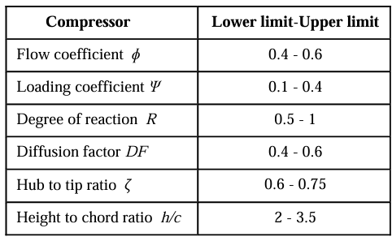

Table 1: given value ranges.

phi = 0.6;

epsi = 0.379285;

R = 0.5;

h_c = 3.5;

For maximizing the efficiency and decreasing the number of stages the following was chosen:

|  |  |  |
| --- | --- | --- |
| Coefficient | Value chosen | Reason |
| Flow Coefficient Φ | Maximum (0.6) | Decreases the number of stages. |
| Loading Coefficient Ψ | 0.379285 | Changing the number until the number of stages is a whole number. |
| Degree of reaction R | Minimum (0.5) | Decreases the number of stages. |

Table 2: chosen coefficients values.

**1.4 Calculations**

### 1.4.1 Compressor total temperature ratio

Taw_c = 1+(pi_c^(0.4/1.4)-1)/eta_c

Taw_c = 1.4097

dela_t_c = (Taw_c-1)*Tt1

dela_t_c = 117.9962

### 1.4.2 Velocity triangles

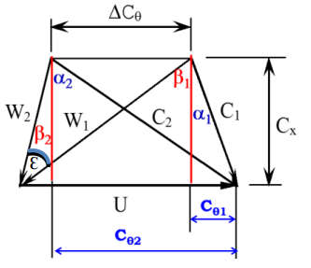

Figure 1: velocity triangle.

### 1.4.3 Velocity triangle 1

beta1 = atan((R+0.5*epsi)/phi)*180/pi

beta1 = 48.9762

alpha1 = atan((1-R-0.5*epsi)/phi)*180/pi

alpha1 = 27.3508

Ctheta1 =Cx*tan(alpha1*pi/180)

Ctheta1 = 77.5894

Wtheta1 = Cx*tan(beta1*pi/180)

Wtheta1 = 172.4106

W1 = Cx/cos(beta1*pi/180)

W1 = 228.5288

C1 = Cx/cos(alpha1*pi/180)

C1 = 168.8790

### 1.4.4 Velocity triangle 2

beta2 = atan((R-0.5*epsi)/phi)*180/pi

beta2 = 27.3508

alpha2 = atan((1-R+0.5*epsi)/phi)*180/pi

alpha2 = 48.9762

Ctheta2 =Cx*tan(alpha2*pi/180)

Ctheta2 = 172.4106

Wtheta2 = Cx*tan(beta2*pi/180)

Wtheta2 = 77.5894

W2 = Cx/cos(beta2*pi/180)

W2 = 168.8790

C2 = Cx/cos(alpha2*pi/180)

C2 = 228.5288

U = W1*sin(beta1*pi/180)+C1*sin(alpha1*pi/180)

U = 250

rm = 60*U/2/pi/N %blade mean radius

rm = 0.2387

### 1.4.5 Stage Work

W_s = U*(Ctheta2-Ctheta1)*mdot

W_s = 1.1853e+06

### 1.4.6 Stage temperature increase

Tt2 = Tt1 + W_s/mdot/1004.5

Tt2 = 311.5991

delta_t_s = Tt2-Tt1

delta_t_s = 23.5991

### 1.4.7 number of stages



Z = dela_t_c/delta_t_s

Z = 5.0000

### 1.4.8 Total compressor work

W = W_s*Z

W = 5.9264e+06

### 1.4.9 calculation of solidity

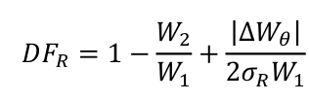 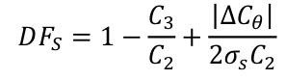 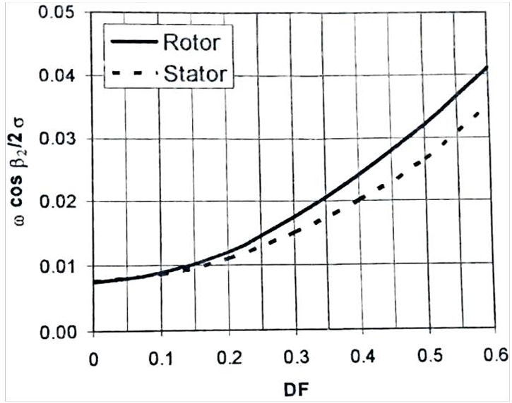

Figure 2: DF vs efficiency graph.

Solidity_r = abs(Wtheta1-Wtheta2)/2/W1/(DF+W2/W1-1)

Solidity_r = 0.8681

Solidity_s = abs(Ctheta1-Ctheta2)/2/C2/(DF+C1/C2-1)

Solidity_s = 0.8681

%from graph

omega_r = 0.0315;

omega_s = 0.0265;

### 1.4.10 calculation of temperatures and pressures

For rotor

T1 = Tt1-C1^2/2/1004.5

T1 = 273.8038

Ttrel1 = T1+W1^2/2/1004.5

Ttrel1 = 299.7996

T2 = Tt2-C2^2/2/1004.5

T2 = 285.6034

Ttrel2 = T2+W2^2/2/1004.5

Ttrel2 = 299.7996

P1 = Pt1*(T1/Tt1)^(1.4/0.4)

P1 = 8.4895e+04

Ptrel1 = P1*(Ttrel1/T1)^(1.4/0.4)

Ptrel1 = 1.1661e+05

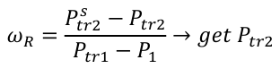

Ptrel2 = Ptrel1-omega_r*(Ptrel1-P1)

Ptrel2 = 1.1562e+05

P2 = Ptrel2*(T2/Ttrel2)^(1.4/0.4)

P2 = 9.7561e+04

Pt2 = P2*(Tt2/T2)^(1.4/0.4)

Pt2 = 1.3234e+05

For stator

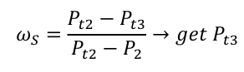

Pt3 = Pt2-omega_s*(Pt2-P2)

Pt3 = 1.3142e+05

### 1.4.11 Stage adiabatic efficiency

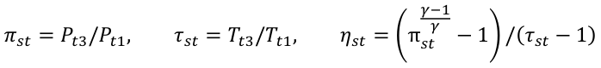

pi_s = Pt3/Pt1

pi_s = 1.2970

Taw_s = Tt2/Tt1

Taw_s = 1.0819

eta_s = (pi_s^(0.4/1.4)-1)/(Taw_s-1)

eta_s = 0.9413

### 1.4.12 Geometry



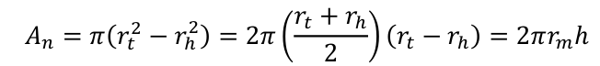

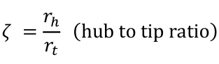

rho1 = P1/287/T1

rho1 = 1.0803

rho2 = P2/287/T2

rho2 = 1.1902

A1 = mdot/rho1/Cx

A1 = 0.3085

A2 = mdot/rho2/Cx

A2 = 0.2801

h = A1/2/pi/rm

h = 0.2057

r_hub = (2*rm-h)/2

r_hub = 0.1359

r_tip = h+r_hub

r_tip = 0.3416

zeta = r_hub/r_tip

zeta = 0.3978

### 1.4.13 Calculation of Mach number at different stages

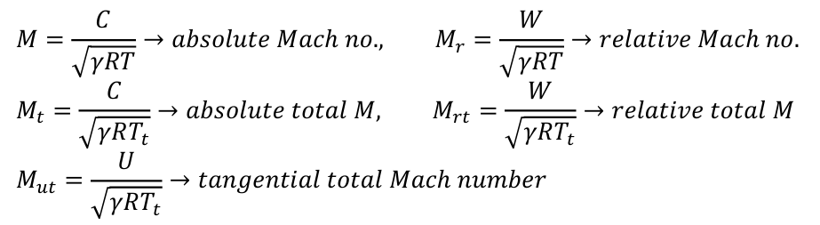

For state 1

M1 = C1/sqrt(1.4*287*T1)

M1 = 0.5092

Mt1 = C1/sqrt(1.4*287*Tt1)

Mt1 = 0.4964

Mr1 = W1/sqrt(1.4*287*T1)

Mr1 = 0.6890

Mrt1 = W1/sqrt(1.4*287*Tt1)

Mrt1 = 0.6718

Mut1 = U/sqrt(1.4*287*Tt1)

Mut1 = 0.7349

For state 2

M2 = C2/sqrt(1.4*287*T2)

M2 = 0.6746

Mt2 = C2/sqrt(1.4*287*Tt2)

Mt2 = 0.6459

Mr2 = W2/sqrt(1.4*287*T2)

Mr2 = 0.4985

Mrt2 = W2/sqrt(1.4*287*Tt2)

Mrt2 = 0.4773

Mut2 = U/sqrt(1.4*287*Tt2)

Mut2 = 0.7065

### 1.4.14 Blade angles

using NACA 65-(15)10 airfoil

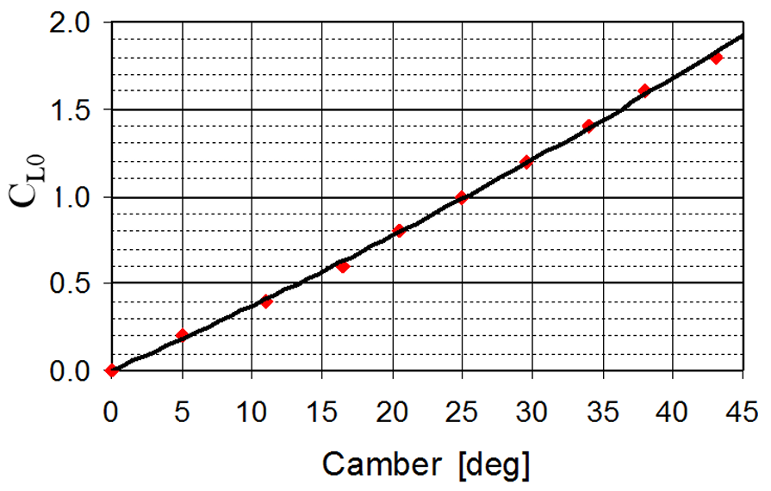

Figure 3: CLo vs Camber graph.

% from graphs

camber_angle = 36

camber_angle = 36

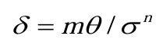 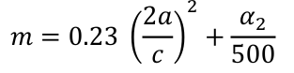

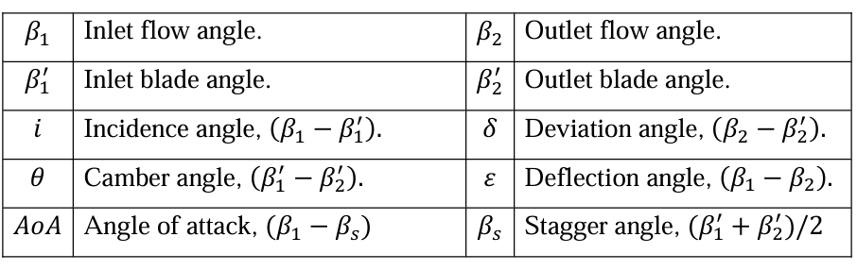

Table 3: angles calculations

m = 0.23*(2*0.5)^2+alpha2/500

m = 0.3280

deviation_angle = m*camber_angle/Solidity_r^0.5

deviation_angle = 12.6716

blade_angle_2 = beta2-deviation_angle

blade_angle_2 = 14.6793

blade_angle_1 = camber_angle+blade_angle_2

blade_angle_1 = 50.6793

incidence_angle = beta1-blade_angle_1

incidence_angle = -1.7031

deflection_angle = beta1-beta2

deflection_angle = 21.6254

stagger_angle = (blade_angle_1+blade_angle_2)/2

stagger_angle = 32.6793

AoA = beta1-stagger_angle

AoA = 16.2969

### 1.4.15 estimating axial compressor length and number of blades

chord = h/h_c

chord = 0.0588

length = 2*chord*Z+chord

length = 0.6465

Z_blades = ceil(2*pi*rm*Solidity_r/chord)

Z_blades = 23

1. **Off design problem**

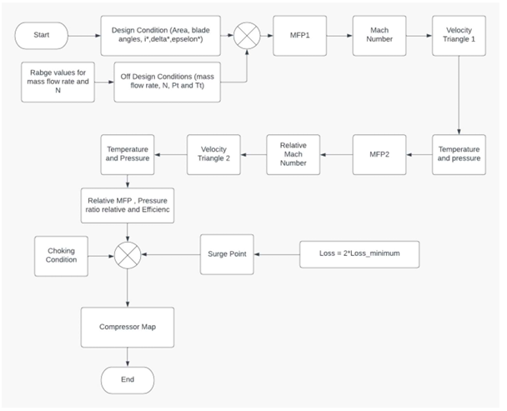

Figure 4: problem approach.

* 1. **Inlet Gide vanes’ function**

In this section we design a MATLAB function that calculate outlet condition of inlet Gide veins

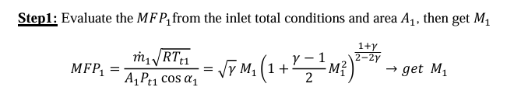

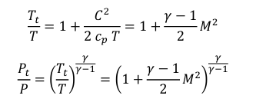

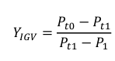

function [Pt1,Tt1,alpha1,P1,M1,P0,T0]=igvsoff(Pt0,Tt0,md,A,alpha1_des)  
y_loss=0.03; % offdesign loss coefficient for IGV  
options = optimset('Display','off');  
alpha1=alpha1_des; %For inlet guide vane the losses remains constant for M1<=0.5  
[Mo]=fsolve(@(Mo) (md*sqrt(287*Tt0))/(Pt0*A*cosd(alpha1))-(sqrt(1.4)*Mo/((1+.2*Mo^2)^3)),.35,options);  
P0=Pt0/((1+.2*Mo^2)^3.5);  
T0=Tt0/(1+.2*Mo^2);  
Tt1=Tt0;  
% To calc the pressure substitute in loss equation for IGV  
[x]=fsolve(@(x) [x(1)-x(2)*(1+.2*x(3)^2)^3.5; y_loss-(Pt0-x(1))/(x(1)-x(2));...  
md*sqrt(287*Tt1)/(x(1)*A*cos(alpha1*pi/180))-sqrt(1.4)*x(3)*(1+.2*x(3)^2)^(-3)],[10^5 9*10^4 .5],options);  
Pt1=x(1);  
P1=x(2);  
M1=x(3);

* 1. **Off design Calculations function**

function [Pt3,Tt3,alpha3,max_eff,inced1,inced2]=offdesign(Pt1,Tt1,mdot,u1,A1,A2,alpha1)

options = optimset('Display','off');

* 1. **Fitting of The Losses Curve**

x_inc=[-.8 -.6 -.4 -.2 0 .2 .4 .6 .8];  
y_loss=[.47 .3 .19 .1 .07 .1 .19 .3 .47];  
w_loss=polyfit(x_inc,y_loss,2);

* 1. **Fitting of The Deviation Curve**

x_inc=[0 0.2 0.4 0.6 0.8];  
y_dev=[0 0.05 0.2 0.4 0.7];  
d_dev=polyfit(x_inc,y_dev,2);

* 1. **At design**

delta_des = 12.76; % [deg] eps=beta2-beta2d  
eps_des = 21.64; % [deg] eps=beta1-beta2  
i_star=-1.703; % [deg] same incidence angle for stator and rotor due to symmetry

* 1. **Across Rotor**



Figure 5: velocity triangle (off design)

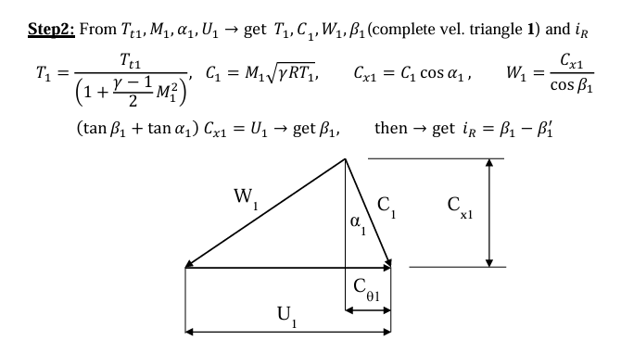

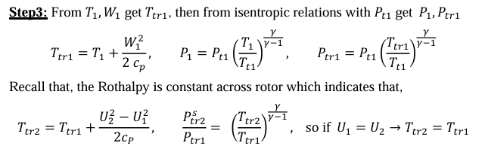

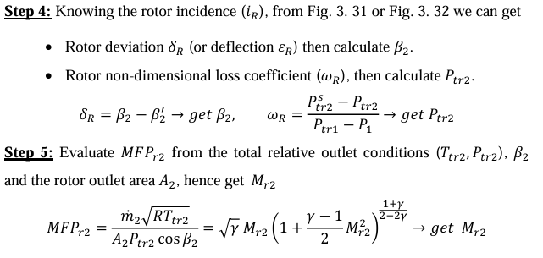

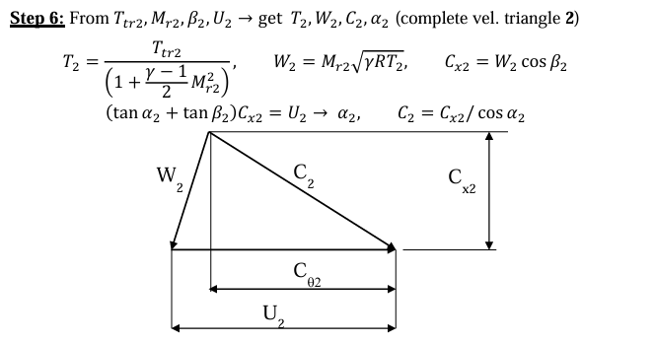

Figure 6: outlet velocity triangle:

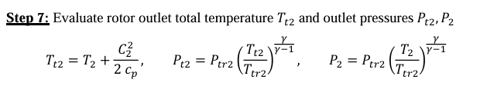

beta1d=41.7; % [deg]  
beta2d=16.7; % [deg]  
[M1]=fsolve(@(M1) (mdot*sqrt(287*Tt1))/(Pt1*A1*cos(alpha1*pi/180))-(sqrt(1.4)*M1*(1+0.2*M1^2)^-3),.5,options);  
T1=Tt1/(1+.2*M1^2);  
P1=Pt1/((1+.2*M1^2)^3.5);  
c1=M1*sqrt(1.4*287*T1);  
cx1=c1*cos(alpha1*pi/180);  
cth1=c1*sind(alpha1);  
wth1=u1-cth1;  
beta1=atand(wth1/cx1); %[deg]  
i_r=beta1-beta1d;  
inc_r=(i_r-i_star)/(eps_des);  
max_eff=0;  
% In Order To Give Indication That The Incidence Exceed The Staling limits  
% (I Assume The Limits Are That of The Range Of The Given Curves)  
if (inc_r > .8) || (inc_r < -.8)  
 max_eff=1;  
end  
if inc_r <=0  
 dev_r=0;  
else  
dev_r=polyval(d_dev,inc_r);  
end  
deltar=dev_r*eps_des+delta_des; % [deg]  
beta2=(beta2d+deltar); %[deg]  
wr=polyval(w_loss,inc_r);  
w1=cx1/cos(beta1*pi/180);  
Ttr1=T1+(w1^2/(2*1004.5));  
Ptr1=P1*((Ttr1/T1)^3.5);  
Ptr2=Ptr1*(1-wr)+P1*wr;  
Ttr2=Ttr1; %Since Rothalpy is constant across the Rotor  
[Mrel2]=fsolve(@(Mrel2) (mdot*sqrt(287*Ttr2))/(Ptr2*A2*cos(beta2*pi/180))-(sqrt(1.4)*Mrel2*((1+.2*Mrel2^2)^-3)),0.4,options);  
T2=Ttr2/(1+.2*Mrel2^2);  
P2=Ptr2/((1+.2*Mrel2^2)^3.5);  
w2=Mrel2*sqrt(1.4*287*T2);  
cx2= w2*cos(beta2*pi/180);  
wth2=w2*sin(beta2*pi/180);  
cth2=u1-wth2;  
c2=sqrt(cx2^2+cth2^2);  
M2=c2/sqrt(1.4*287*T2);  
Tt2=T2*(1+.2*M2^2);  
Pt2=P2*((1+.2*M2^2)^3.5);

* 1. **Across Stator:**

alpha2d=60; %[deg]  
alpha3d=40; %[deg]  
Tt3=Tt2; %Since No Heat added and no work across the rotor  
alpha2=atan(cth2/cx2)*(180/pi); % [deg]  
i_s=alpha2-alpha2d;  
inc_s=(i_s-i_star)/(eps_des);  
if (inc_s > .8) || (inc_s < -.8)  
 max_eff=1;  
end  
if inc_s <=0  
 dev_s=0;  
else  
dev_s=polyval(d_dev,inc_s);  
end  
deltas=dev_s*eps_des+delta_des;%[deg]  
alpha3=alpha3d+deltas; % [deg]  
  
ws=polyval(w_loss,inc_s);  
Pt3=Pt2*(1-ws)+ws*P2;  
inced1=(beta1-beta1d); %[deg] Incidence to rotor  
inced2=(alpha2-alpha2d); %[deg] Incidence to stator

## from design problem

U=250;  
m_dot_des=50;  
Pt0=10^5;  
Tt0=288;  
A=[ 0.2801 0.3085 0.2801 0.3085];  
alpha1_des=27.3508;  
n_stage=1;  
pi_c_des=3;  
i_star=-1.703;  
delta_star=12.62;  
epsi_star=21.64;

## Calculations

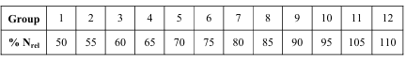

Table 4: Nrel for teams

But we are group 14 so we use Nrel=120

N_rel=[0.5:0.1:1.4];  
mdot_rel=[0.1:0.005:1.4];  
for count1=1:length(N_rel)  
 U_off=U*N_rel(count1);  
 Limt1=0;  
 for count2=1:length(mdot_rel)  
 mdot=mdot_rel(count2)*m_dot_des;  
 [Pt1,Tt1,alpha1,P1,M1,P0,T0]=igvsoff(Pt0,Tt0,mdot,A(1),alpha1_des);  
 for n=1:n_stage  
 [Pt3,Tt3,alpha3,max_eff,ince_off(2*n),ince_off(2*n+1)]=offdesign(Pt1,Tt1,mdot,U_off,A(2*n),A(2*n+1),alpha1);  
 Pt1=Pt3;  
 Tt1=Tt3;  
 alpha1=alpha3;  
 end  
 mfpout_off=mdot*sqrt(Tt3)/Pt3;  
 pic_off=Pt3/Pt0;  
 toic_off=Tt3/Tt0;  
 etac_off=(pic_off^(.4/1.4)-1)/(toic_off-1);  
 % Applying The Condition That Efficiency is Between 0 & 1 %  
 if (etac_off > 1) | (etac_off < 0) | (max_eff == 1)  
 else  
 pic_rel(count1,count2)=pic_off/pi_c_des;  
 etac_rel(count1,count2)=etac_off;  
 % To Get The surge points %  
 if pic_rel(count1,count2) > Limt1  
 picmax(count1)=pic_rel(count1,count2);  
 mdmin(count1)=mdot_rel(count2);  
 beg(count1)=count2;  
 Limt1=pic_rel(count1,count2);  
 end  
 mdrr(count1,count2)=mdot_rel(count2);  
 en(count1)=count2;  
 end  
  
 end  
end

## plots

for count1=1:length(N_rel)  
 plot(mdrr(count1,beg(count1):en(count1)),pic_rel(count1,beg(count1):en(count1)),'color',rand(1,3),'LineWidth',3)  
 hold on  
end  
surge=polyfit(mdmin,picmax,5);  
plot(mdot_rel,polyval(surge,mdot_rel),'b-.','LineWidth',2)  
axis([0.2 0.6 0.2 0.6])  
legend('At Part Speed = 50%','At Part Speed = 60%','At Part Speed = 70%','At Part Speed = 80%','At Part Speed = 90%','At Part Speed = 100%','At Part Speed = 110%','At Part Speed = 120%','At Part Speed = 130%','The Surge Line','The Operating Line')  
title('Compressor Map','FontWeight','bold','color','b')  
xlabel('MFP)_{rel}','FontWeight','bold','color','r')  
ylabel('\pi_{c})_{rel}','FontWeight','bold','color','r')  
grid on  
  
figure(2)  
for count1=1:length(N_rel)  
 xi = mdrr(count1,beg(count1):en(count1));  
 zi = etac_rel(count1,beg(count1):en(count1));  
 plot(xi,zi,'color',rand(1,3),'LineWidth',3)  
 hold on  
end  
legend('At Part Speed = 50%','At Part Speed = 60%','At Part Speed = 70%','At Part Speed = 80%','At Part Speed = 90%','At Part Speed = 100%','At Part Speed = 110%','At Part Speed = 120%','At Part Speed = 130%','The Surge Line')  
title('Efficiency Variation','FontWeight','bold','color','r')  
xlabel('MFP)_{rel}','FontWeight','bold','color','b')  
ylabel('\eta_{c})_{rel}','FontWeight','bold','color','b')  
grid on

1. **compressor Surge**
   1. **Introduction**

Compressors are workhorses in various industries, playing a critical role in processes ranging from refrigeration and air conditioning to natural gas transportation and power generation. Their function is simple: to increase the pressure of a gas. However, operating a compressor comes with a crucial limitation – surge. This part delves into the intricacies of compressor surge, exploring the surge line, surge point, and surge cycle. It further examines the detrimental effects of the surge, the limited benefits it offers, and various strategies for preventing and detecting this unwanted phenomenon.

* 1. **Understanding the Limits: Surge Line and Surge Point**

### 3.2.1 Surge Line:

Compressor performance is often visualized on a performance map with mass flow rate on one axis and pressure ratio on the other. The surge line on this map represents the boundary between stable and unstable operating conditions for the compressor. It's not a single point but a curve that encompasses various operating conditions where instabilities like surges can occur. The shape and position of the surge line depend on various factors, including compressor design, speed, and inlet conditions.

### 3.2.2 Surge Point:

While the entire surge line signifies potential instability, a specific point on this line marks the critical limit. This point represents the operating condition where the compressor can no longer maintain stable flow against the system's resistance (pressure drop across the compressor). Beyond this point, a surge sets in. Operating a compressor even close to the surge line is risky, as any minor disturbance can push the operating point into the unstable zone.

## **3.3 The Unwanted Guest: Surge Cycle and its Effects**

### 3.3.1 Surge Cycle:

When a surge occurs, the flow through the compressor momentarily reverses. This creates a characteristic cycle on the performance map. The operating point oscillates rapidly between the high-pressure discharge side and the low-pressure suction side, causing significant pressure fluctuations and vibrations. This cycle can repeat several times per second, leading to a highly unstable operating condition.

### 3.3.2 Effects of Surge:

Surge is highly detrimental to compressor performance and can lead to several negative consequences:

* + **Reduced Efficiency:** The flow reversal and instability during surge disrupt the normal compression process, leading to a significant decrease in compressor efficiency.
  + **Increased Wear and Tear:** The rapid pressure fluctuations and vibrations caused by the surge put immense stress on the compressor's internal components, accelerating wear and tear on blades, impellers, bearings, and seals.
  + **Potential Damage:** In severe surge events, the intense forces can lead to structural damage to blades, impellers, and other compressor components. This can necessitate costly repairs or even complete compressor replacement.
  + **System Instability and Process Upsets:** Surge can cause significant pressure fluctuations throughout the entire system connected to the compressor. This can disrupt downstream processes and potentially lead to safety hazards.
  1. **Surge: A Double-Edged Sword? (Pros and Cons)**

There's no upside to the surge itself. However, understanding the surge line provides some benefits:

* **Safe Operational Boundaries:** Knowing the surge line allows engineers to set safe operating limits for the compressor. By keeping the operating point well within the stable region of the performance map, surge can be prevented.
* **Compressor Design:** During the design phase of a compressor, surge line data is crucial. It helps engineers optimize the compressor's performance for expected operating conditions and ensure it can handle the required pressure ratios without entering the surge zone.
  1. **Keeping the Flow Going: Surge Control Strategies**

Since surge is highly undesirable, various strategies are employed to prevent it:

### 3.5.1 Inlet Guide Vanes (IGVs):

These adjustable vanes are located at the compressor inlet. By adjusting the angle of the IGVs, the flow entering the impeller can be regulated. This allows for fine-tuning the compressor's performance and keeping the operating point away from the surge line.

### 3.5.2 Anti-Surge Valves:

These valves act as a safety measure. During potential surge situations, an anti-surge valve opens a bypass route, diverting some gas flow from the compressor discharge back to the inlet. This reduces the pressure rise across the compressor, preventing it from entering the surge zone. However, using an anti-surge valve comes at the cost of reduced compressor efficiency.

### 3.5.3 Variable Speed Drives (VSDs):

Modern compressors can be equipped with variable speed drives. By adjusting the compressor's speed, the operating point on the performance map can be shifted. This allows for adapting the compressor's performance to varying system demands while keeping it away from the surge line.

### 3.5.4 Control Systems:

Sophisticated control systems are employed in modern compressor applications. These systems continuously monitor various compressor parameters, such as pressure, flow rate, and speed. By analyzing these parameters in real time, the control system can take corrective actions.

* 1. **How do we plot the surge line in MATLAB?**
  2. In each operating line detect the surge point -the point at which the maximum pressure ratio and minimum mass flow rate-
  3. Save all of these points in a vector
  4. Use poly-fit order in MATLAB to get the polynomial equation of the surge line. Give it surge points and the polynomial degree and it will return the equation
  5. Use poly-Val order in MATLAB to evaluate the value of surge at different mass flow rates. Give it the surge equation and mass flow rate vector.
  6. Plot surge line equation after evaluation in the y-axis with a mass flow rate in the x-axis



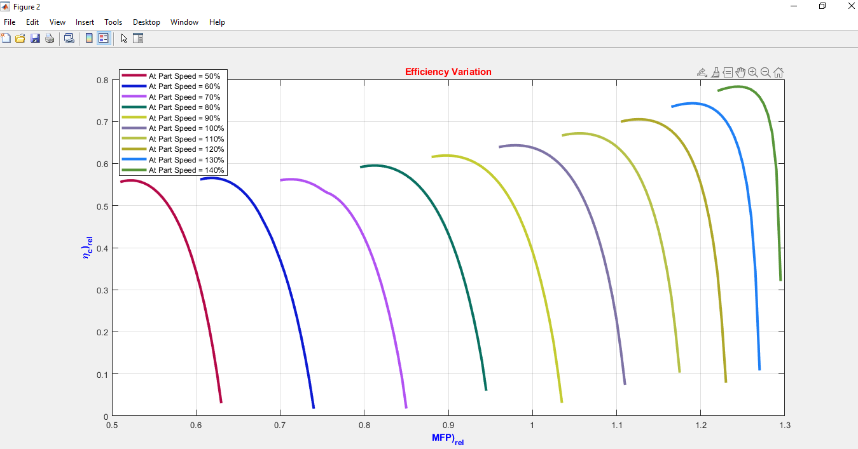

Figure 7: Efficiency variation.

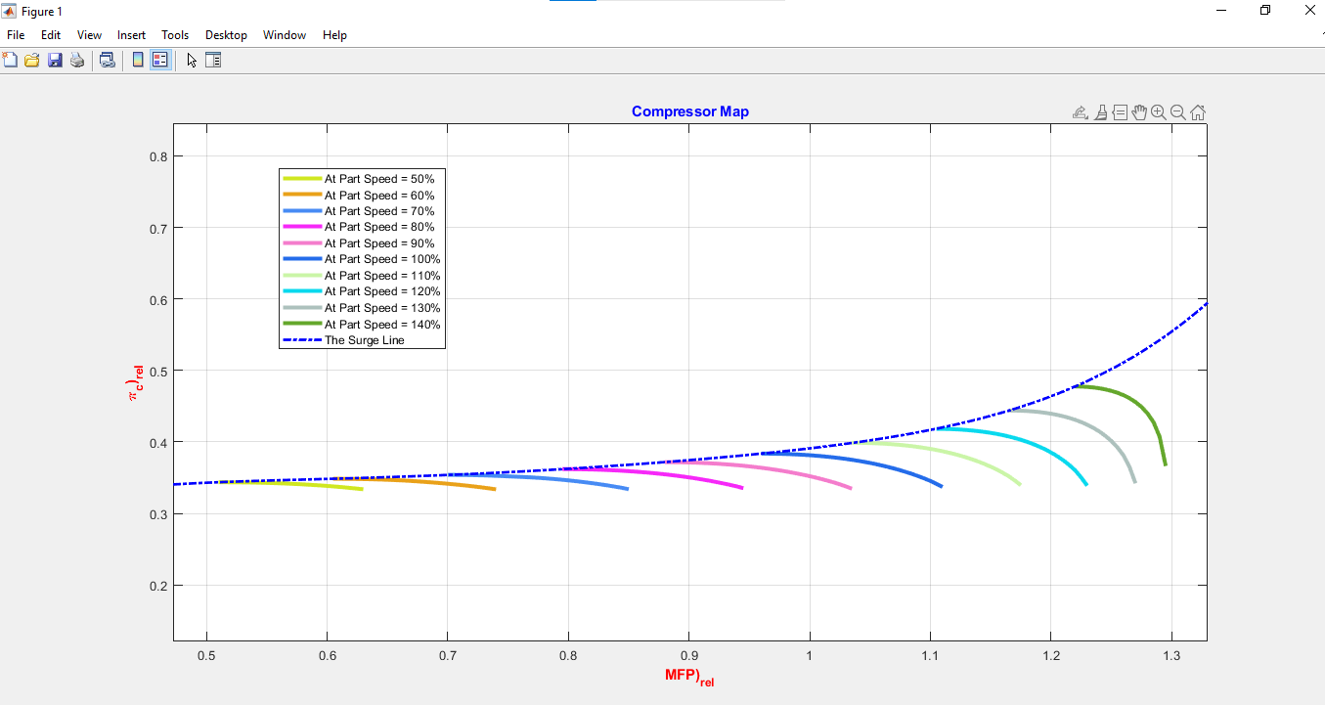

Figure 8Compressor map.

1. **CFturbo**
   1. **Introduction**

CF Turbo is a user-friendly computational fluid dynamics (CFD) software tailored for analyzing and optimizing turbomachinery components like pumps and fans. It offers intuitive geometry creation, automated mesh generation, comprehensive simulation setup, and efficient post-processing tools. With CF Turbo, engineers can swiftly design, simulate, and optimize fluid flow systems across various industries, saving time and enhancing product performance. Our main focus while using it was the geometry which will be later on used on Ansys software for further CFD analysis.

Figure 9: CFturbo Logo

* 1. **Methodology**

The design methodology involves iterative steps, starting from initial geometry creation to final optimization. CFturbo software is utilized for geometric modeling, blade design, and flow path optimization. The methodology emphasizes performance-driven design iterations to achieve the desired compressor characteristics.

* 1. **Geometry Creation**

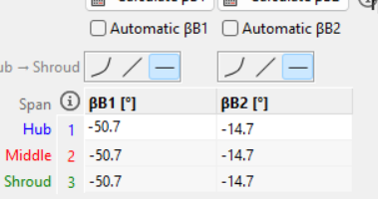The geometry creation phase involves defining the compressor's basic geometry, including blade profiles, hub, and shroud contours. CFturbo's intuitive interface is utilized to create and modify the compressor geometry according to design requirements and constraints. A design case was solved using a MATLAB code giving us the parameters needed to start working on the CFturbo software. The code provided necessary inputs for the geometry including rm which was calculated to be 238.7 mm with a hub and shroud radius of 135.9 mm and 341.6 mm and blade angles for IGV (0 ,14.679), Rotor (50.6793, 14.6793) & Stator (50.6793, 14.6793) these were the main values needed to commence the work.

Figure 10: inserting rotor blade angles in CF turbo.

* 1. 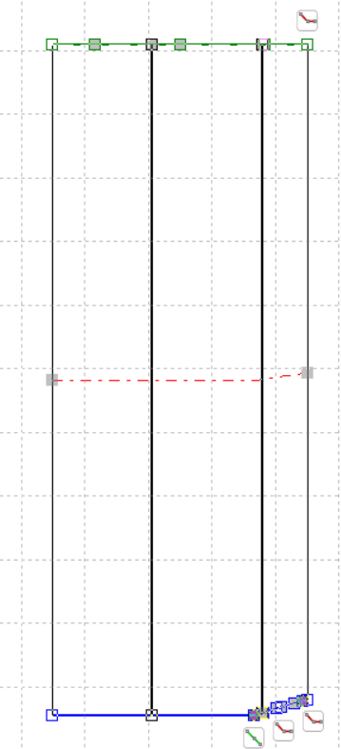 **Blade Design**

Blade design is a critical aspect of axial compressor performance. CFturbo's blade design module allows for the creation of custom blade profiles, including chord length, twist angle, and stacking parameters. The blade design process focuses on optimizing aerodynamic performance and minimizing losses.

* 1. **Meridional Flow Path**

The meridional flow path design determines the overall shape and dimensions of the compressor's flow channel. CFturbo's meridional contour editor is employed to define the flow path geometry, including inlet and outlet shapes, throat area, and diffusion characteristics. The meridional flow path is optimized to achieve uniform flow distribution and minimize losses.

Figure 11: IGV.

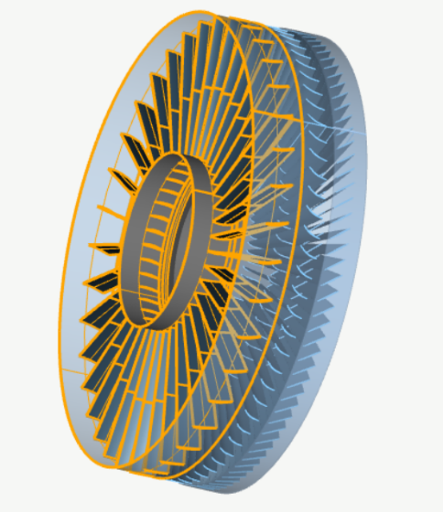**4.6 Optimization**

Figure 12: 3D Model.

Optimization techniques, such as parameter sweeps and genetic algorithms, are employed to refine the compressor design iteratively. CFturbo's optimization tools facilitate rapid exploration of design space and identification of optimal configurations. The optimization process aims to maximize compressor performance while satisfying design constraints.

**4.7 Conclusion**

In conclusion, the utilization of CFturbo software in the design and optimization of the axial compressor geometry has been instrumental in achieving our project objectives efficiently. By leveraging its user-friendly interface and robust features, we were able to create, simulate, and optimize the compressor geometry with precision and accuracy. The initial geometry parameters obtained from the MATLAB code provided a solid foundation for our design process, ensuring that we started with relevant and accurate inputs. Through iterative steps, focusing on blade design, meridional flow path optimization, and overall performance-driven design iterations, we were able to refine the compressor geometry to meet the desired performance criteria. The optimization techniques available in CFturbo enabled us to explore the design space effectively and identify optimal configurations that maximize compressor performance while adhering to design constraints. Overall, CFturbo has proven to be a valuable tool in our workflow, streamlining the design process and paving the way for further analysis using ANSYS software. With the optimized compressor geometry in hand, we are well-positioned to conduct comprehensive CFD analysis and further refine our design for enhanced performance and efficiency.

# 5.0 Turbo grid and CFX

**5.1 CFturbo Software Analysis**

* The following figure shows the CF turbo meridian plane with accurate dimensions and blade angles.

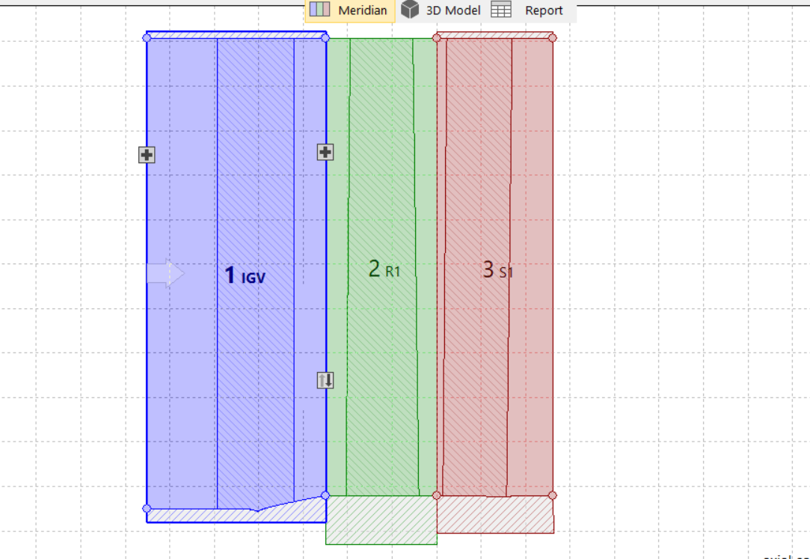

Figure 13: blades on CFturbo.

* The following is the Ansys workbench we constructed

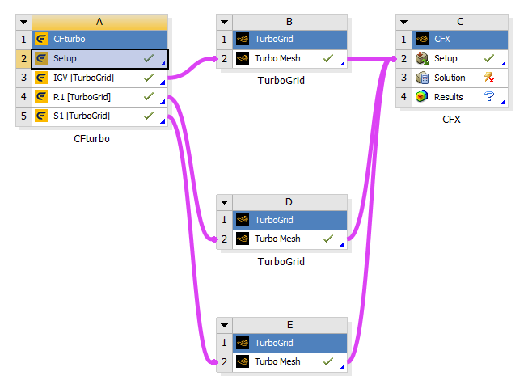

Figure 14: Ansys workbench.

* Meshed full Compressor with rotor stator and IGVs.

Figure 15: segment ready for analysis.

* Established boundary conditions including inlet conditions, rotational speed, and geometric parameters.

Figure 16: establishing boundary conditions.

* Evaluated compressor performance metrics such as pressure ratio, efficiency, and flow characteristics.
* Imported the geometric model from CF Turbo into Ansys.
* Meshed the geometry to ensure computational accuracy and efficiency.
* Applied boundary conditions including inlet pressure and temperature, rotational speed, and material properties.
* Conducted steady-state simulations to analyze fluid flow, pressure distribution, and temperature distribution within the compressor stage.
* Evaluated the performance of the compressor stage by comparing simulation results with CF Turbo predictions.

**5.2 Ansys Simulation Run**

### 5.2.1 Velocity calculations on ANSYS

Figure 17: C1 on Ansys.

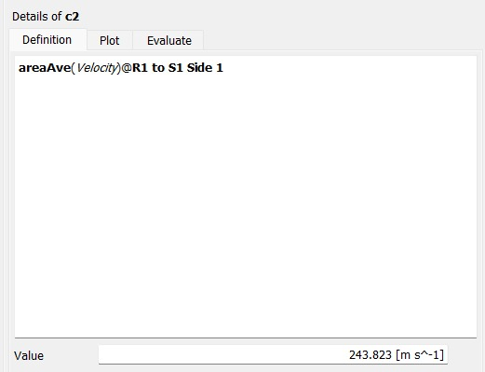

Figure 18: C2 on Ansys.

Figure 19: W1 on Ansys.

Figure 20: W2 on Ansys.

### 5.2.2 From MATLAB calculations

Figure 21: velocities calculations from MATLAB.

### 5.2.3 For the pressure calculations

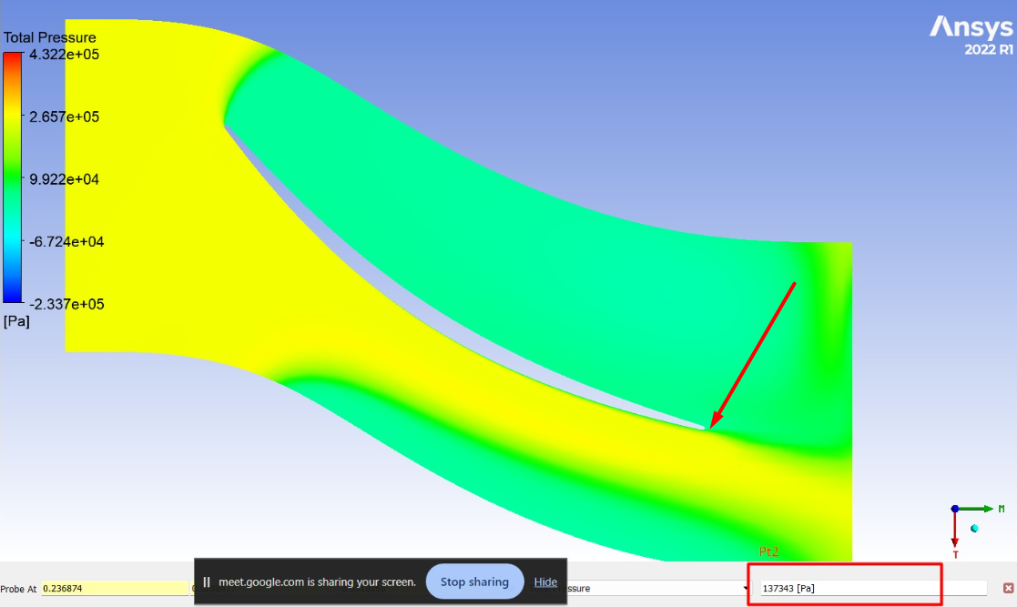

Figure 22: PT2 on Ansys.

Figure 23: PT3 on Ansys.

5.2.4 From the MATLAB calculations

Figure 24: pressures from MATLAB.

### 5.2.5 Comparison Table

|  |  |  |  |
| --- | --- | --- | --- |
| Parameter | MATLAB | CFD | Error |
| C1 | 168.87 | 136.75 | 19% |
| C2 | 228.5288 | 243.823 | 6.7% |
| W1 | 228.5288 | 227.252 | 0.55% |
| W2 | 168.878 | 172.048 | 1.877% |
| PT2 | 1.3234e+05 | 1.3734e+05 | 3.77% |
| PT3 | 1.3142e+05 | 1.32985ee+05 | 1.2% |

Table 5: comparison between MATLAB and Ansys values for velocities and temperatures.

### Conclusion

The analysis of an axial compressor stage with Inlet Guide Vanes using CF Turbo software and Ansys provided valuable insights into the performance characteristics and design optimization of such systems.

CF Turbo Analysis:

* Optimal geometric parameters were identified to maximize compressor efficiency while maintaining a desirable pressure ratio.

Ansys Simulation:

* Simulation results demonstrated good agreement with CF Turbo predictions, validating the accuracy of the preliminary analysis.
* Pressure and temperature distributions across the compressor stage were visualized, highlighting areas of high stress and potential flow separation.
* Efficiency and pressure ratio obtained from Ansys simulations corroborated the findings from CF Turbo analysis, providing further confidence in the design.

# 6 References

<https://youtu.be/p5ky0cqn1TM?si=xbYNbLw5D5tk0oqm>